OCEAN BREEZE
We Put Your Mind at Ease

YOUR OUTDOOR REMODELING SPECIALISTS

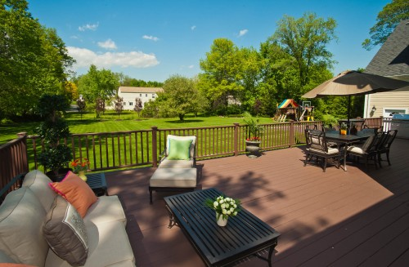

By: Mark A Priganc
Date: 22-MARCH-2013

Contents

Executive Summary
BUSINESS GOALS and OBJECTIVES
Mission Statement
Vision Statement
PRODUCTS and SERVICES
Products
Services
MARKET SUMMARY
Industry Overview
Demographics
Economic Trends
Political/ Legal Trends
COMPETITIVE ANALYSIS
Competition
Products and Brands
Services
S.W.O.T ANALYSIS
Strengths
Weaknesses
Opportunities
Threats
MARKETING STRATEGIES
Marketing Objectives
Financial Objectives
Growth Strategy
TARGET MARKET
Market Needs
Market Growth

Executive Summary

Along the Grand Strand area there are numerous options for people to purchase their outdoor living dreams. With this in mind, moving forward Ocean Breeze needs to consider the options presented within this marketing plan. Given the current state of transition of this business not all plans may be feasible or desirable at this time. Although, all plans in this report are obtainable.

With the real estate downturn of the past several years more people are inclined to stay put in the home they currently reside in. Or, with the desirability of this area, ‘near retirees’, are more likely to purchase a home in this area to live out their days. They are using their retirement funds to purchase their retirement home, before they actually retire, while the prices are down. Estimates of the rebound for values will take it 15-20 years. At the time of this writing, the prices have begun to slowly inch their way back up. The babyboomers stared to retire in 2009. The babyboom lasted for 18 years.

“As a group, they were the wealthiest, most active, and most physically fit generation up to that time, and amongst the first to grow up genuinely expecting the world to improve with time. They were also the generation that received peak levels of income…”

Seemingly the economic times of the past six years would damage the growth of a small business like Ocean Breeze. But, solid implementation of the right marketing mix Ocean Breeze can and will dominate the market niche of Outdoor Living.

With the US economy and housing market now recovering, investment in the nation’s housing inventory is also picking up. Lenders and new owners are rehabilitating millions of foreclosed properties. Older homeowners are retrofitting their homes to accommodate their future needs. Households in general are increasing their investments in environmentally sustainable improvements. And with the huge echo-boom population moving into the home-buying market over the coming decade, the remodeling industry can look to an even more promising future.
The Joint Center for Housing Studies, Harvard University

BUSINESS GOALS and OBJECTIVES

Mission Statement

Giving the Grand Strand Area, the most enjoyable Outdoor Living Experience. While Providing Quality Craftsmanship, Using the Highest Grade Materials. All, while maintaining a reasonable profit margin in order to ensure the longevity of the company.

Vision Statement

To be the First and Only company that any Homeowner within our service area thinks of for their Outdoor Living Dream

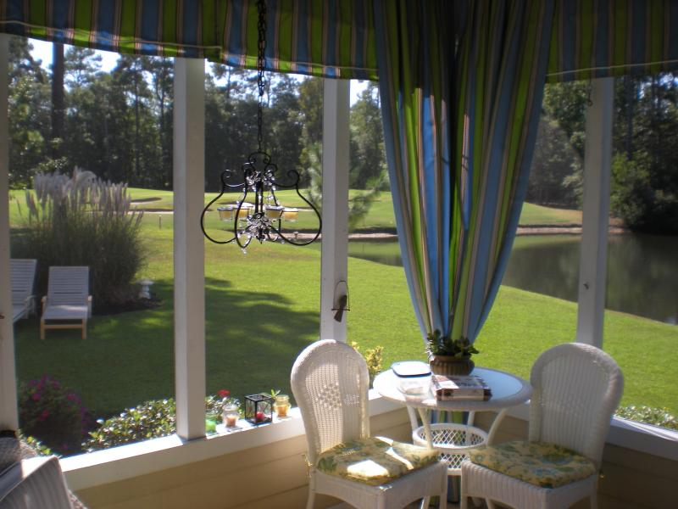

PRODUCTS and SERVICES

Products

The current product mix that you are offering is adequate to sustain sales. There are additional products that can be offered that can grow the business. The majority of the marketing should be focused on the core products that fall into the High Involvement Feeling sector of the matrix.

Services

Services are an enormous opportunity. With the addition of services Ocean Breeze can add substantial revenue to the bottomline. Implemented correctly over a given timeline, a service division to the business could easily add 30-40% to total annual revenue. A list of services that can be added to the existing business model are contained in the appendix.
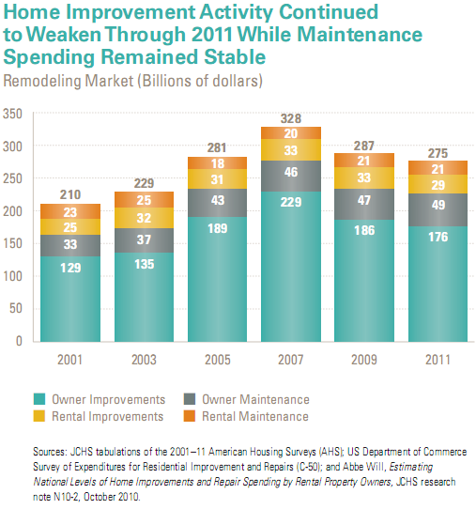

MARKET SUMMARY

Industry Overview

In this section we are looking at the national state of the industry. Later on the focus will shift to the local level of the industry.
The magnitude of the housing bust that began in the middle of the past decade is well documented, with a 75-percent plunge in housing starts, a 45-percent decline in existing home sales, and a, 30–35 percent slide in house prices. Less well known is how the ensuing cutbacks in residential investment (including spending on both home building and improvements) have eroded the condition of the national housing inventory.

The Joint Center for Housing Studies, Harvard University

The remodeling industry as a whole tends to increase when the real estate sales and new construction sectors stagnate and decline. During the 2007 to 2011 downturn, spending on maintenance and repairs increased by about 6 percent, while spending on improvements dropped by 22 percent. Although the remodeling sector did see a double digit drop in spending by homeowners from 2007 to 2011, the industry is trending upward again and at a significant pace- in the double digit range.

“How rapidly growth proceeds depends on many critical factors: international political and financial events; the ability of Congress and the Administration to effectively manage fiscal policy; and continued improvement in private sector business conditions, leading to job and income growth for US households. The availability of credit to homeowners for improvement projects is also uncertain.” The Joint Center for Housing Studies, Harvard University

“Despite these unknowns, some niche markets are already laying a firm foundation for renewed growth in home improvement spending. In particular, the upgrading of more than 4.2 million distressed homes sold between 2009 and 2012 has already generated a burst of expenditures. The 2.9 million homes currently in, or at serious risk of, foreclosure thus represent pent-up demand for future investment. Given the strong growth in the number of renter households since the housing crash, owners of rental housing are likely to upgrade their properties in the coming years.” The Joint Center for Housing Studies, Harvard University

“Years of underinvestment in the nation’s housing stock have expanded the market for home improvements. In particular, the growing supply of homes that have been through the protracted foreclosure process represents a major opportunity for remodeling firms. In 2011 alone, renovations of just over a million distressed properties generated about $10 billion in spending. With nearly 3 million additional homes currently in or at risk of foreclosure, many more billions will be necessary to upgrade these properties for return to the market.”
The Joint Center for Housing Studies, Harvard University
Demographics

Baby Boomers are now in their mid-40s to mid-60s. The baby boomers have dominated the housing market ever since they began to form households in the late 1960s and 1970s. Although their dominance declined somewhat during the latest housing boom as younger generations entered the market in record numbers, they regained prominence once the bust hit.
One reason for the relatively strong home improvement spending by older households is that they have remained employed longer. In the depths of the recession in 2009, the national unemployment rate hit 9.3 percent. Among workers age 55 and over, however, the jobless rate was just 6.6 percent and it has held about 2.0 percent below the national average ever since. This trend is especially noteworthy given that the share of the population age 55 and over in the labor force (either working or actively looking for work) has climbed steadily from 30 percent in 1990 to 40 percent today.
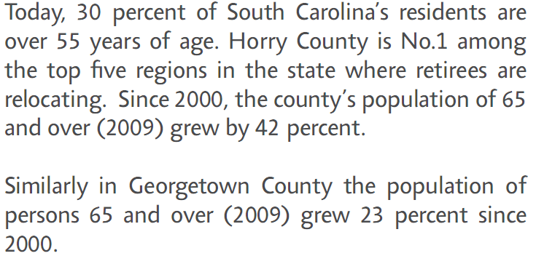

21st Edition Statistical Abstract * MyrtleBeachAreaChamber.com
Homeowners in this age group also fared better than younger owners during the housing downturn in that they lost a smaller share of their home equity. Since home equity represents a large portion of household wealth for most Americans, older owners have been more fortunate in this regard as well. In fact, the median inflation-adjusted net worth of the age 55-and-over homeowner population fell less than a third as much on a percentage basis as that of the under-55 population between 2007 and 2010.

At the same time, the housing market crash helped to drive down the relatively low mobility rates of older homeowners (the share that moves to new residences in a given year) even further. The mobility rate for owners age 45–64 fell from 4.1 percent in 2007 to 3.1 percent in 2011, while that for owners age 65 and over dipped from 2.7 percent to 1.8 percent.

Even if mobility rates return to more traditional levels as the housing market recovers, the overwhelming majority of older homeowners prefer to remain in their current homes as they age. Retrofitting their homes to accommodate their changing needs thus represents a significant opportunity for the remodeling industry. So far, many older households have yet to make these modifications. For example, although a majority of owners age 55 and older have a bedroom on the first floor to avoid stairs, only a third have wheelchair-accessible kitchens, and fewer than one in six have raised toilets, door handles rather than knobs, or wider doorways and hallways for easier navigation. Younger owners are even less likely to have such features in their homes.

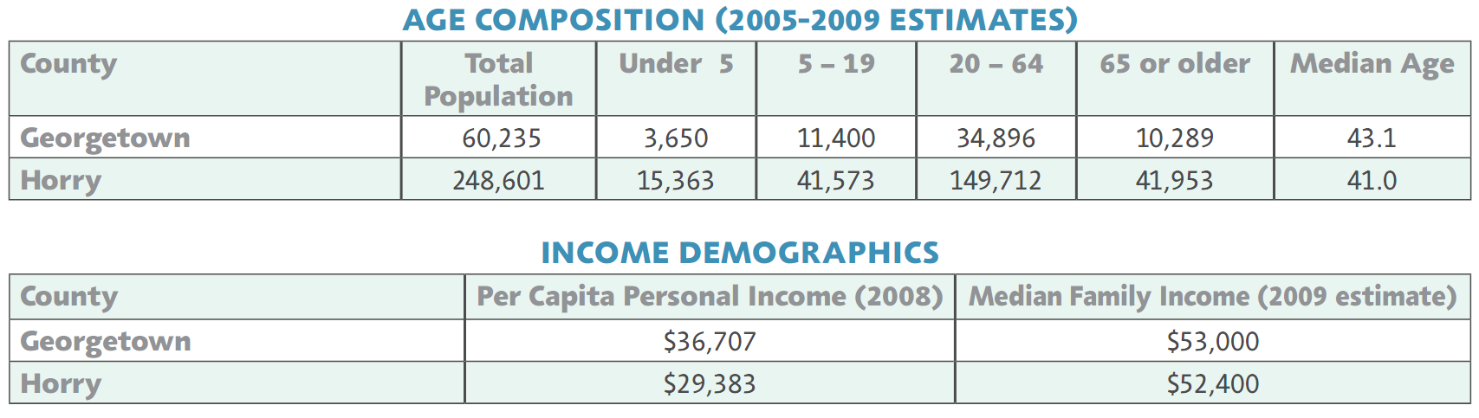

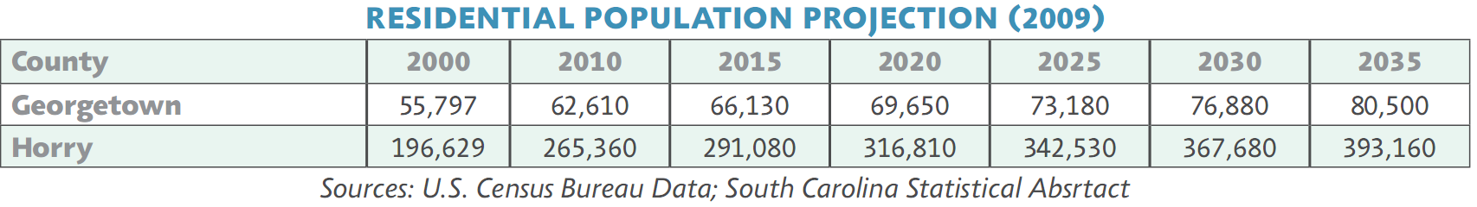

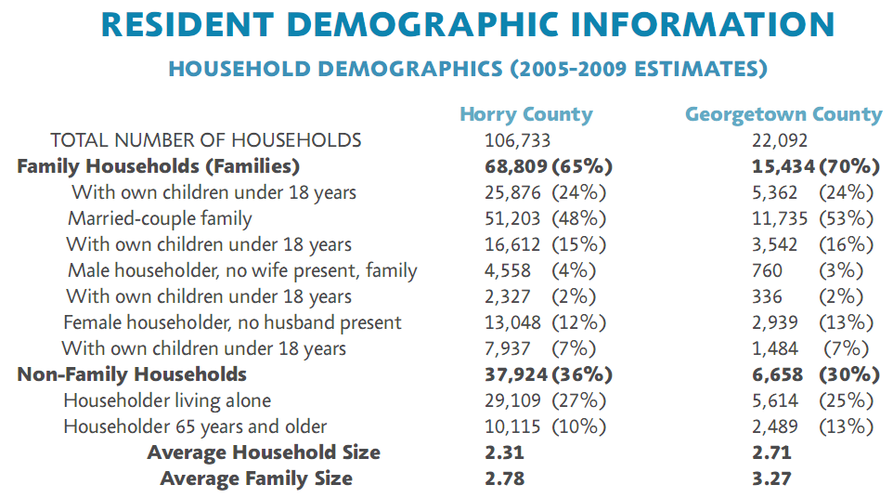

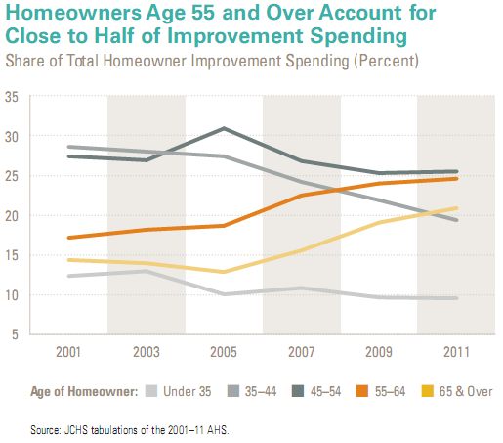
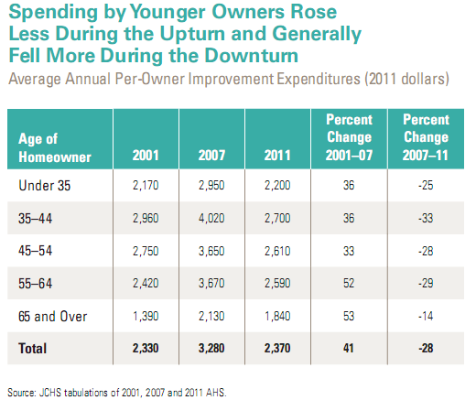

Economic Trends

This is a very unpredictable area. Especially with the, volatility in the markets over the past decade. As of the writing of this report the market surpassed its highest point in the past five years. Looking back to the previous section, Ocean Breeze’s target market is reaping returns in their retirement accounts. The question remains as to whether they will begin to withdraw funds for improvements to age in place or buy a retirement home and make improvements to it for their aged years.

As households age, their home improvement spending grows. For example, the baby-bust generation (born between 1965 and 1984) was just beginning to enter the homebuying market in 1995 and thus accounted for only 5 percent of improvement spending by owners in that year. Their share of improvement expenditures jumped to 27 percent in 2005 and then to almost a third of the market in 2011. Given that the oldest members of the echo-boom(born between 1985 and 2004) generation were only in their mid-20s in 2011 and just beginning to pursue homeownership, their share of improvement spending was only about 1 percent that year.
The sheer number of younger households bodes well for the remodeling industry. In the meantime, though, the housing downturn, weak economic recovery, and tight credit environment have deterred these households from buying homes. As a result, the homeownership rate among households under age 35 dropped from 43 percent in 2005 to just over 36 percent in the third quarter of 2012. The decline among households age 35–44 was equally sharp, from about 69 percent to less than 62 percent.

COMPETITIVE ANALYSIS

Competition

“According to Joint Center estimates of the most recent Economic Census of the Construction Industry, more than 650,000 contractors served the remodeling market at the peak of the housing boom in 2007. Fully two-thirds of these remodelers were self-employed, but even most of those with payrolls were also small. Indeed, more than 70 percent of payroll establishments posted less than $500,000 in revenue that year, and fully half reported revenues below $250,000. By comparison, only 31 percent of single-family home builders—and less than 15 percent of building materials and supplies dealers—had receipts of less than $250,000 in 2007.” The Joint Center for Housing Studies, Harvard University

Competition will vary depending on the job that is being proposed. Competition can actually
change with each job. In the appendix several different examples of competition are profiled to
include specific information for each company that offers the same and or similar products and
services as Ocean Breeze.

Competition within this specific industry is very dynamic, and in constant flux. Pretty much
anyone with some tools and a little bit of skill can effectively enter the market and potentially
take away some smaller jobs. The economic condition of the past six to seven years have shown
this to be a true and somewhat harmful phenomenon for the industry. Harmful in a way of
promoting distrust toward all companies within the industry. These are hurdles that will be
discussed and covered in the SWOT section of this plan.

Products and Brands

The products and brands that Ocean Breeze currently utilizes are very well known locally as well
as nationally. Product and brand recognition on a national scale is vitally important especially in
this area. Every year more and more retirees are relocating to this area to live out their days.
They bring with them pre-conceived thoughts of what they want in their home at the beach.

As this shift of age in the population takes root, products for an aged population needs to be
introduced into the offerings of Ocean Breeze. In the coming years and decades there is
tremendous opportunity for new age related products that Ocean Breeze can capitalize on. But,
only by being ahead of the curve, and establishing the reputation now.

Services

Services at Ocean Breeze are greatly lacking at this time. There are numerous services that Ocean Breeze can implement over time that can have a significant impact on the bottom line. Many of the services could actually be contracted out to approved vendors through contractual agreements. Implementation should begin with finding vendors that offer services that Ocean Breeze can add on to current offerings, as part of the sale or back-ended as additional service after the job. My suggestion would be to start with pressure washing. Customers just upgraded their home with a new deck or sunroom, this is the time to get the entire property looking fresh and new. Additional services, gutter cleaning, storm preparedness, etc.. The list of services that can be offered is endless. As we covered earlier in this plan, the population is aging. This older demographic, either can’t do the chores or are not willing to do them. This scenario is opportunity for Ocean Breeze to increase revenue/ profit. The younger population, that are buying starter homes, in Ocean Breeze’s operating area, don’t have the time to do the chores around the house and are willing to pay someone to do them. Again, additional revenue opportunities. With so many vacation homes (absentee owners) pre-storm preparations can be a substantial income stream.

S.W.O.T ANALYSIS

The information derived in this section is taken from the pre-plan survey. The business should
perform a SWOT analysis at a minimum of every six months. An ideal scenario would be to
perform this task, at least informally, every quarter. Looking at the four variables that make up
the SWOT analysis on a regular basis keeps the principles of the business aware of their
marketplace as well as internal health of the company.

Strengths

From the outset of this analysis. Ocean Breeze holds a solid position in the marketplace. You
Have adapted to changing needs of customers through the years and offered the right products at
the right time. Ocean Breeze has longevity in the marketplace, which lends to referrals and
potential repeat business. Another strength is owner participation in the daily operations of the
business, not, just in the office but also on job sites.

Weaknesses

Weaknesses are present in all businesses. The principles willingness to address the weaknesses
oftentimes is the difference between success and failure. The greatest weakness to any business
is ‘The Status Quo’. Ocean Breeze has not totally escaped this weakness (no business can).
Ocean Breeze’s most obvious weakness is the age of the principle owner. After 26 years in
business it is expected that the owner will begin to tire and not be as aggressive in decisions and
promotions as he once was. This is realistically an unavoidable situation. This leads to another
weakness, no definitive exit strategy for the principles of the business. All businesses and
investments should be made with the end (an exit) in mind. An unwillingness to expand into
some services will hurt the health of the company over time.

Opportunities

Opportunities for Ocean Breeze are literally everywhere. As stated above from looking at the
statistics and demographics of the business some lite-interior rehabs can be significant
enhancements to the overall revenue of the company. The population is aging, and there are
special consideration and needs with this group. Another glaring opportunity is in the ‘Green
Energy’ sector. Homeowners are looking to save as much money as they can while maximizing
their return-on-investment.
The opportunities for Ocean Breeze are so numerous, we can’t even begin to list them here. The
approach to capitalizing on these opportunities is to think outside the box of just staying with the
status quo.

Threats

Threats are in line with the weaknesses that we have already addressed. Threats could come from
government regulations within any of the supplier industries that Ocean Breeze uses. Supplier
vulnerabilities can hurt Ocean Breeze. Ocean Breeze should monitor the health of their supplier,
and be on the lookout for weakness and vulnerabilities within those companies. A companies
threats can also come from within. Owner apathy can destroy a company as quickly as
oppressive government regulations. Ocean Breeze needs to be flexible with product offerings
and address threats quickly and effectively.



MARKETING STRATEGIES

Marketing Objectives

The objectives of all marketing Ocean Breeze sends to the market is to convert as many eyes on
the marketing into a customer, whether a new or returning customer. Look to past marketing
campaigns and set new objectives for the new campaigns. The shortfall of past campaigns can be
overcome with effective ad copy, and scripts for the radio medium. A campaign should not be
undertaken if definitive metrics cannot be applied to measure the success or failure of the
medium. Measurable results are the key to increasing marketing effectiveness.

Financial Objectives

Financial objectives of marketing should always be to increase year-over-year revenue from the
ad or medium. As we just stated, measurable results are the key to successful marketing. Not all
mediums are effective for all industries or demographics. Marketing needs to be a major
consideration of your annual budget. The percentage of annual sales allotted to marketing should
be sufficient enough to increase overall revenue to the desired point.

Example: $1,000,000 Annual Sales x 4%-8%= $40,000 to $80,000 Annual budget for marketing

Established businesses often make the mistake of thinking everybody knows who and where they
are, and what they do. Therefore they reduce their marketing. That mistake is fatal for many
businesses.

Growth Strategy

The growth strategy should be in line with the financial objectives. The more prominent Ocean
Breeze is in the market and thus the minds of potential and past customers the more growth can
be recognized. Looking back at the core demographics of Ocean Breeze, we see it is skewed to a
somewhat older population (55-70). Historical campaigns that Ocean Breeze has run should
begin a gradual transition to the Internet. The Internet has been around for approximately 15
years. That puts the low end of your target demographic, in a fairly familiar sense of how to use
the Internet. They will be more comfortable using it, and buying online. As the lower end of the
age demographic moves through your core group those entering it will be more and more
accustomed to making decisions from the Internet.

TARGET MARKET

Market Needs

The needs of the target market are not completely being served with what Ocean Breeze
currently offers. The needs of this demographic are changing and Ocean Breeze needs to be
in front of the curve for their needs. Ocean Breeze needs to look beyond the edge of the deck.
There are incredible revenue resources beyond the edge. Something immediately in thought is
some landscaping, or raised plant beds to enhance the view from the customers new deck.

There are also needs by your target market within the house. Something as simple as changing
out door knobs for door handles can add significant revenue to Ocean Breezes bottom line.

As the target market ages, they are in need for more services that they can no longer do on their
own. Adding services to the business can be an incredible revenue boost.

Market Growth

The target market for Ocean Breeze is part of the largest birth boom this country has ever seen,
and will probably ever see. This means significant growth opportunity for Ocean Breeze. But,
only if you are willing to expand into services and go beyond the edge of the deck. More and
more people within the core demographic age range are moving to the Grand Strand, and
therefore expanding the overall size of the market. They are coming here for the prospect of not
having to deal with snow in the winter.

